**Project Report**

**on**

**AR-Based Indoor Navigation System**

in partial fulfilment for the award of the degree of

**BACHELOR OF ENGINEERING**

IN

**B.E CSE AI&ML**

**Submitted by:**

PRAGY SHARMA (24BAI70247)

SIMRAN CHOUHAN (24BAI70124)

MANAN VERMA (24BAI70008)

**Under the Guidance of**

Divneet Singh Kapoor

**ACADEMIC UNIT-I**



**Chandigarh University**

**April 2025**

**Index**

|  |  |  |
| --- | --- | --- |
| **S. No.** | **Content** | **Page No.** |
| 1 | Project Overview | 1 |
| 2 | Objective and Problem Statement | 2 |
| 3 | Proposed Solution & Methodology | 3 |
| 4 | Key Findings / Results | 5-8 |
| 5 | Conclusion & Learnings | 9 |
| 6 | References | 10 |
| 7 | Appendix (if required) |  |

## 1. Project Overview

*The* ***AR-Based Indoor Navigation System*** *is an innovative solution designed to address the challenges of indoor navigation, where traditional GPS systems fail due to signal obstruction. Unlike outdoor environments, GPS signals are often blocked in indoor spaces like shopping malls, hospitals, airports, and office buildings. This creates confusion and inefficiencies, particularly for first-time visitors or those unfamiliar with the layout of a space. As a result, the need for an intuitive and efficient indoor navigation system has become critical.*

Our project utilizes **Augmented Reality (AR)** technology to provide real-time visual guidance, helping users navigate indoor environments with ease. By using smartphones equipped with AR capabilities, the system overlays visual markers such as arrows, signs, and labels directly onto the user’s screen. These visual cues act as guiding points, ensuring users reach their desired destinations smoothly.

Developed using **Unity 2021+** along with **AR Foundation** and **Immersal SDK**, the system maps indoor spaces through the smartphone’s camera and sensors, creating a detailed 3D map made up of high-density point clouds. These maps enable precise location tracking without relying on GPS or external hardware such as Bluetooth beacons, QR codes, or Wi-Fi-based positioning systems. This makes the system highly scalable, cost-effective, and easy to deploy in a wide range of public spaces.

The key advantage of our system is its ability to function **markerlessly** — meaning it doesn’t require physical markers like QR codes or sensors. Instead, the system tracks the environment in real-time, offering seamless guidance based on the phone’s sensors. This approach eliminates the need for additional hardware installations, reducing both costs and deployment complexity.

### ****Key Features:****

* **Real-time visual guidance via AR**: The system provides step-by-step navigation, displaying arrows and directions that update in real-time as users move through the space.
* **No need for external hardware**: The system operates without Bluetooth beacons, QR codes, or GPS, making it a low-cost, easy-to-deploy solution.
* **Highly scalable**: The system can be adapted for a variety of indoor spaces, such as malls, hospitals, airports, and offices.
* **Smartphone-based and cost-effective**: Since it relies solely on smartphones, it is affordable and doesn’t require the purchase of additional specialized hardware.

This system is not only cost-effective but also flexible, offering a scalable solution that can be deployed in any indoor environment. It promises to enhance the navigation experience, reduce confusion, and improve efficiency for users navigating complex spaces.

*­*

## 2. Objective and Problem Statement

#### *****Objective:*****

The goal of this project is to design and develop a **smartphone-based Augmented Reality (AR) navigation system** that provides **real-time visual guidance** to users within indoor environments. This system leverages **spatial mapping** and **markerless AR techniques** to guide users through complex spaces without requiring additional hardware. By using the smartphone’s camera and sensors, the system offers an interactive and seamless navigation experience, making it easier to navigate indoor spaces such as malls, hospitals, airports, and office buildings.

### ****Problem Statement:****

Traditional **GPS systems** are unable to function effectively indoors due to **signal loss** and the **lack of satellite visibility**. As a result, navigating indoor environments becomes challenging, especially for individuals unfamiliar with the layout. Many existing solutions for indoor navigation rely on **external hardware** such as **Bluetooth beacons**, **QR codes**, or **Wi-Fi-based systems**, which add complexity, installation costs, and maintenance requirements.

There is a clear need for an **accurate**, **scalable**, and **user-friendly indoor navigation system** that works without relying on external hardware. Most current solutions are either hardware-dependent, making them expensive and difficult to scale, or they lack accuracy and ease of use.

This project aims to fill this gap by offering a **cost-effective**, **simple**, and **interactive solution** that uses only **smartphone AR capabilities** and **spatial mapping**. By leveraging the smartphone’s built-in sensors, the system can track and guide users within indoor spaces, offering a fully integrated, hardware-independent solution that is both accurate and easy to implement.

## 3. Proposed Solution & Methodology

*Overview of the Solution:*

Our proposed system relies on **visual mapping** and **AR object tracking** to guide the user through the indoor space. It does not require any GPS, QR codes, or external hardware, which makes it an ideal plug-and-play solution for any building layout.

#### Tools & Technologies Used:

* **Unity 2021+** with AR Foundation: Platform for app development.
* **Immersal Mapper**: Used to scan and generate a 3D map of the target space.
* **Immersal SDK**: Integrated with Unity for spatial localization.
* **Android Smartphone**: Deployment and testing platform.

#### Key Techniques:

* **Markerless AR**: Users do not require physical markers. The system tracks the environment using a mapped point cloud.
* **Visual-Inertial Odometry (VIO)**: Used in the SDK to understand spatial movement and orientation.
* **Cloud Anchors**: Persistent markers are created using visual cues for accurate location-based object placement.

#### Methodology:

1. **Space Mapping**:
   * The room/corridor was scanned using the Immersal Mapper application.
   * A high-density point cloud and mesh were generated and exported for use in Unity.
2. **Unity Integration**:
   * The generated map was imported into Unity and calibrated.
   * AR markers (like arrows and labels) were placed at key locations (e.g., starting point, destination).
3. **Path Definition**:
   * A path was designed using a sequence of visual cues (like 3D arrows or footprints) leading from point A to point B.
   * UI elements for user interaction were added.
4. **Application Development**:
   * The navigation logic, user interface, and AR camera were implemented.
   * User feedback features and restart options were also added.
5. **Testing and Optimization**:
   * The application was deployed on an Android device and tested in real-time.
   * Adjustments were made to improve tracking stability and rendering performance.

**NOTE: DIGRAMMTIC VIEW OF OUR METHODOLOGY-**

## 

## 4. Key Findings / Results

*The final application successfully allowed users to navigate from a starting point to a destination within the mapped room using visual AR markers. The main outcomes and features include:*

* Real-time AR guidance using spatial awareness without GPS or physical markers.
* Accurate user positioning using visual mapping (average offset: < 20 cm).
* Navigation cues were stable, even with moderate user movement and environmental changes.
* The app runs smoothly on mid-range Android devices, with an average frame rate of 30–40 fps.

#### Key Observations:

* Lighting plays a critical role in AR stability.
* The first scan and mapping need to be very detailed for reliable localization.
* The more visual features present in the environment, the better the tracking.

#### Snapshots :

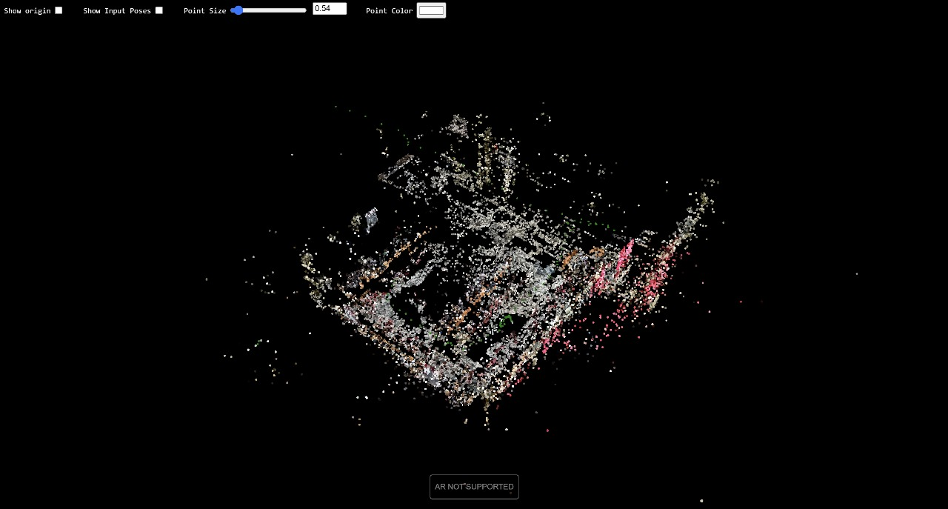FIG 1: (**SPARSE PLY)**

This is the quick scan of the place i.e basic localization

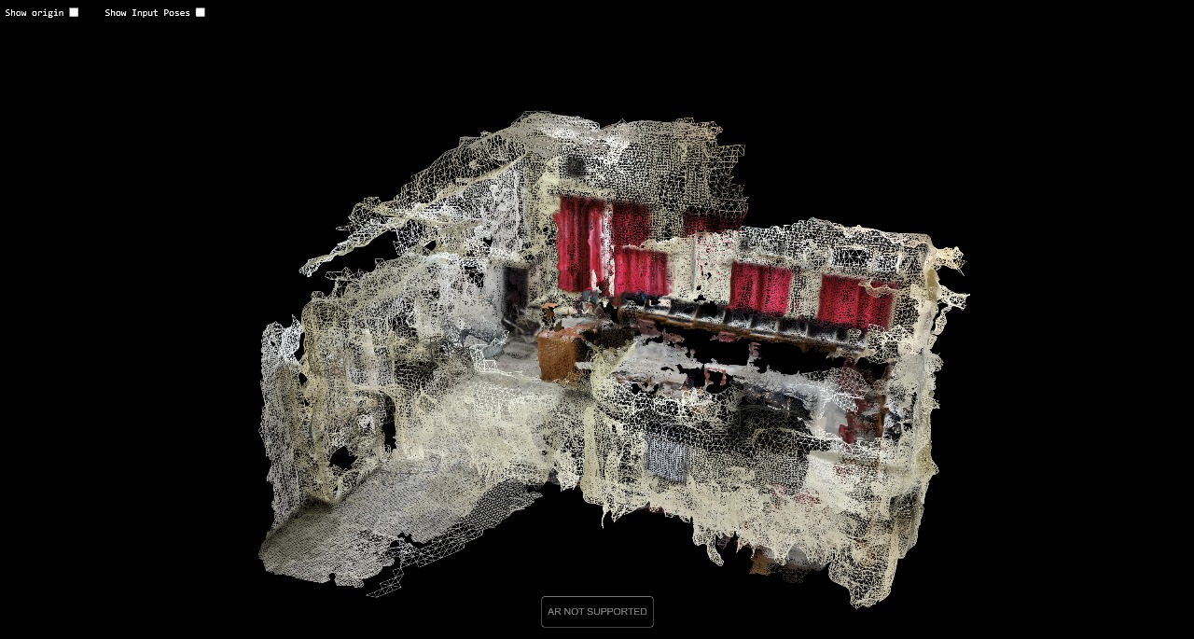FIG 2 ( **DENSE PLY**)

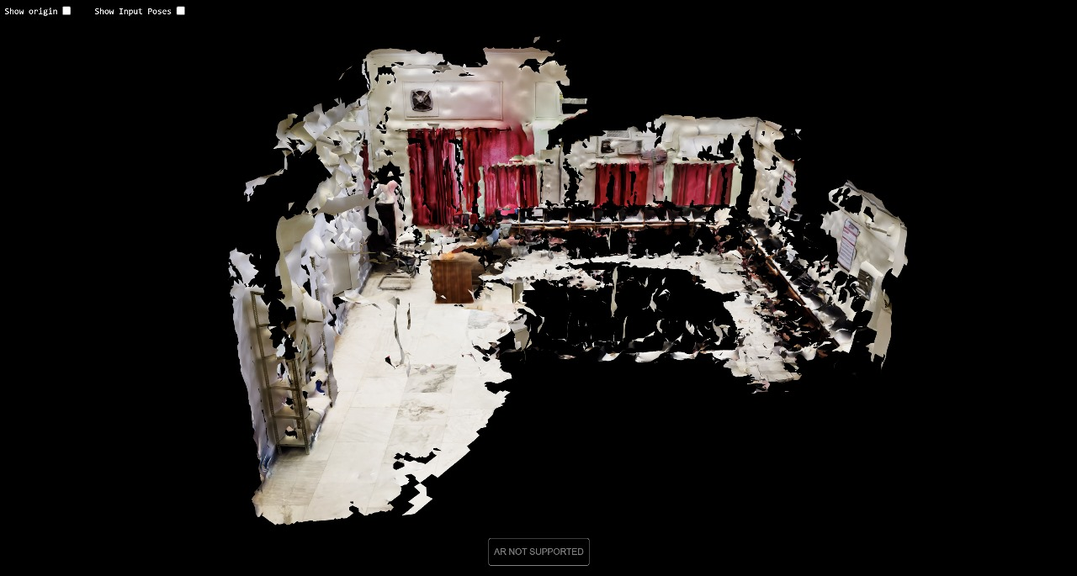This is a high resolution image of the precise placement of AR points in the space , this helps us to track the ar point which visualise the space in our system.

*FIG 3* (***GLB***)

This is a GLB file ( jpeg file for our 3d project ) it contains 3D mesh data ,textures, animation , materials (shaders , surface property)

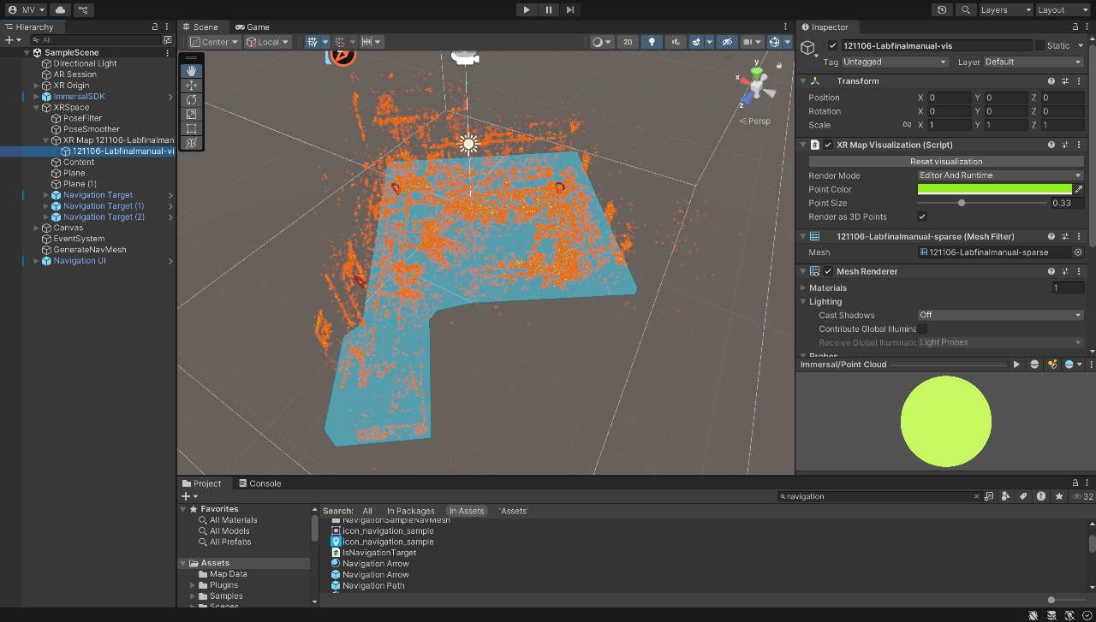 FIG 4

this is the placement of cloud point in the space which later helps us to navigate through the path

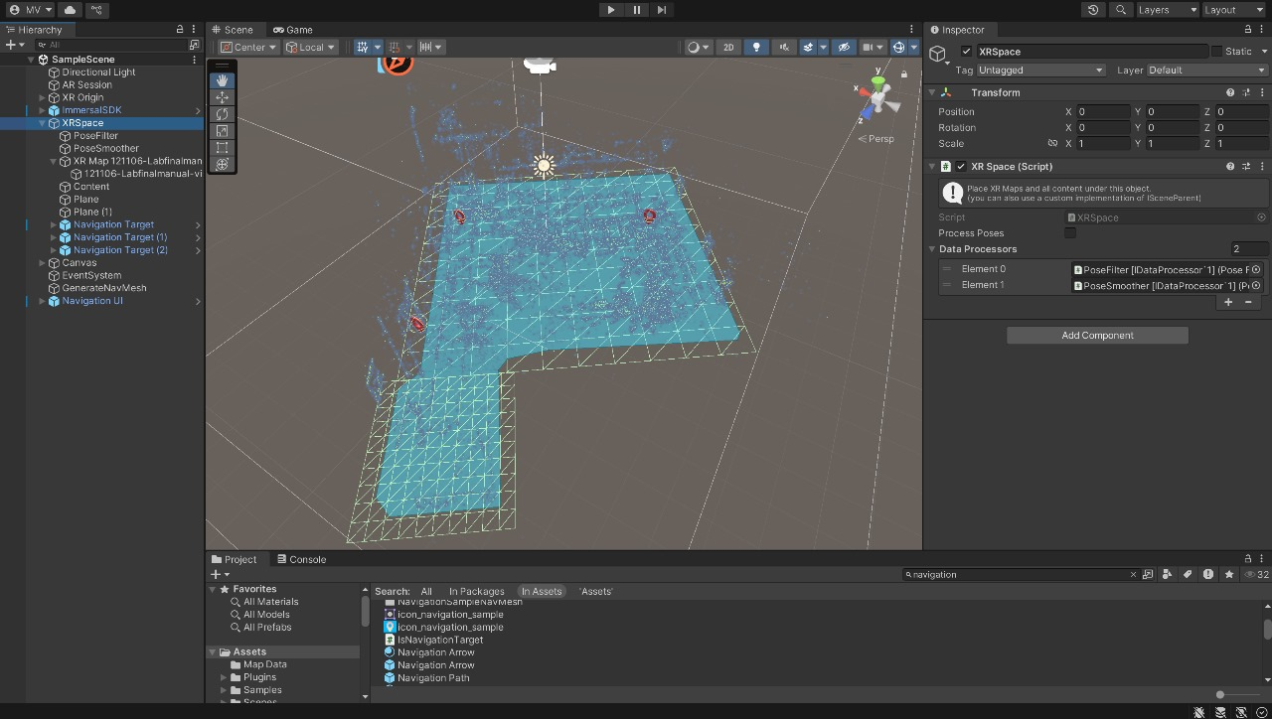FIG 5

this is the Mesh Generation in the space , this technique create a digital surface over the area after the placement of cloud points , the navigation will always appear on the top of this mesh .

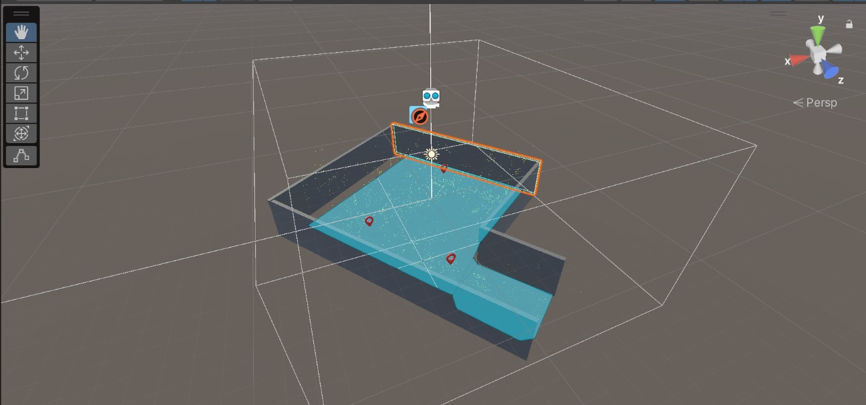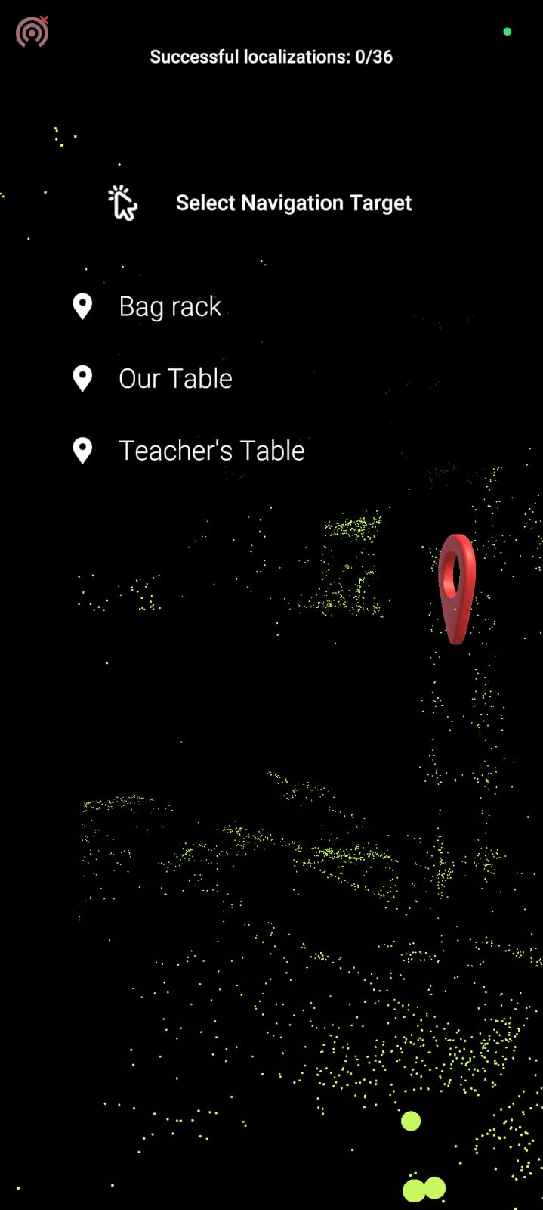FIG. 6   
This is the scene after adding the walls and occlusion just as same as the real room which creates image of the room in the unity interface.

FIG.7  
This is the Android app Interface which is developed by the unity app developer and works on the material we have used in our project in the Unity

This is a direct connection between the

User and the navigator.

User can easily access the navigator using this android app.

## 5. Conclusion & Learnings

*The successful development and testing of the* ***AR-Based Indoor Navigation System*** *clearly demonstrated the potential of using Augmented Reality and spatial mapping for accurate and intuitive indoor navigation. The project validated the idea that GPS-free navigation can be implemented using markerless AR and visual mapping, making it both practical and cost-effective. Our prototype was able to guide users within an indoor environment in real time, using only their smartphone camera and sensors—without relying on any external hardware like Bluetooth beacons, QR codes, or Wi-Fi networks.*

By integrating **Unity** with **AR Foundation** and **Immersal SDK**, we were able to create a stable and functional navigation solution that can be customized and deployed across a variety of settings such as shopping malls, hospitals, educational institutions, exhibition centers, and corporate offices. The project not only achieved its technical goals but also opened new avenues for future improvements in user experience, accessibility, and cross-platform compatibility.

### ****Key Learnings:****

* We gained **hands-on experience with Unity AR Foundation**, understanding how to build AR environments from scratch, integrate 3D objects, manage scene lighting, and optimize performance for mobile devices.
* The use of the **Immersal SDK** gave us valuable exposure to **spatial computing**, especially in creating and handling dense point cloud maps, setting up cloud anchors, and achieving real-time localization.
* We learned about **markerless AR techniques**, where physical markers are not required, and how **visual-inertial odometry (VIO)** plays a crucial role in estimating device movement and orientation indoors.
* Through trial and error, we understood the **importance of environmental factors** such as ambient lighting, surface textures, and clutter, all of which influence the accuracy and stability of AR tracking.
* The project enhanced our **collaborative skills**—from scanning and mapping the space to placing digital markers, testing the app, debugging performance issues, and optimizing the navigation flow.
* We also explored how to structure a user-friendly **interface** that combines both functional and aesthetic elements in a real-time AR experience.

### ****Future Scope:****

While our prototype serves as a solid proof-of-concept, there are multiple areas where the system can be further improved and extended:

* **Multi-destination routing:** Future versions can allow users to select multiple stops or checkpoints within a building and generate optimized paths accordingly.
* **Voice assistance integration:** To enhance accessibility for visually impaired users or those with mobility challenges, the system can incorporate **voice-guided instructions** along with visual AR markers.
* **Cross-platform support:** Currently designed for Android, the system can be expanded to include **iOS compatibility**, making it usable across all major smartphone platforms.
* **AI-powered path generation:** By integrating machine learning algorithms, the system can **automatically generate efficient navigation paths** based on user preferences, crowd density, or real-time obstacles.
* **Dynamic content updates:** Future improvements could include the ability to push real-time updates about route changes, blocked paths, or nearby services (e.g., restrooms, elevators) directly into the AR navigation view.

## 6. References

*Immersal SDK Documentation – https://immersal.com/docs/*

1. Unity AR Foundation Documentation – https://docs.unity3d.com/Packages/com.unity.xr.arfoundation
2. IEEE Paper: “AR-based Indoor Navigation System Using Markerless SLAM” – IEEE Xplore
3. Augmented Reality Essentials by Jerome DiMarzio (Apress Publishing)

## 